­

 Quick Snacks

**Project Report**

**Group Members**

|  |  |
| --- | --- |
| **Name:** | Shaikh Muhammad Taha (1283664)  Hassan Ahmed (1283654)  Ammar Ahmed (1283653)  Adnan Iqbal (1283670) |
| **Batch Code:** | 2010B4 |
| **Faculty:** | Sir Saad Bin Shafi |
| **Coordinator:** | Miss Maha |

**Acknowledgement**

First of all, we would like to thank Almighty Allah who praise us with the ability to think, work and deliver what we were assigned to do. Secondly, we must be grateful to our teacher Sir Saad Bin Shafi who helped us throughout in this project with his constant supervision and support. He has been there to lend his sincere support and advice at all times and had given us invaluable advices, inspiration and suggestion in our journey of knowledge. He gave us the right guidance that has led us to the completion of project. Without his wise advice, this project would not have been possible.

We would also like to express our gratitude to our course coordinator Miss Maha for her trust, support and valuable advice throughout the project.

We are highly indebted and thankful to Aptech for giving us this challenging project as a part of our studies and giving us a chance to prove ourselves.

Lastly, we would like to express our gratitude towards our parents & to each other without the co-operation and encouragement completion of this project was impossible.

**Table of Content**

|  |  |  |  |  |
| --- | --- | --- | --- | --- |
| **Group Members** | | | | **2** |
| **Acknowledgement** | | | | **3** |
| **Table of Content** | | | | **4** |
| 1. | **Introduction** | | | **5** |
|  | 1.1 | | Problem Statement | **5** |
|  | 1.2 | | Requirements | **5** |
|  | 1.3 | | Purpose | **7** |
| 2. | **Website Description** | | | **7** |
|  | 2.1 | Features | | **7** |
|  | 2.2 | Use Case | | **8** |
|  | 2.3 | Site Map | | **9** |
|  | 2.4 | UI | | **10** |
| 3. | **Task Sheet** | | | **18** |
| 4. | **Submission Checklist** | | | **19** |
| 5. | **Conclusion** | | | **20** |

1. **Introduction**
   1. **Problem Statement**

Even though snacking has developed a "bad image," snacks can be an important part of your diet. They can provide energy in the middle of the day or when you exercise. A healthy snack between meals can also decrease your hunger and keep you from overeating at meal time.

We are looking forward to develop a website “Quick Snacks” which will include quick snacks recipes

The website which they demand is supposed to provide user friendly environment and navigation. The important menu must be stated in the top section of the webpage. Also, a decent look out and color combination is expected.

The website is to be developed for the Windows Platform using HTML5, JavaScript and Geolocation. The site should work well in all leading browsers including Chrome, IE, Firefox etc.

* 1. **Requirements and specifications**

The Web site is to be created based on the following requirements.

1. Home page with suitable images /offers should be provided. Navigation links must be included
2. The user should be able to browse through various categories
   1. Healthy Snacks
   2. Snacks for kids
   3. Easy on stomach snacks
   4. Smoothies

User can add more related categories if wish to.

1. When user selects any of the category, the various items should be listed and further if user selects any particular item, details of that item should be displayed. Details should include
   1. Ingredients along with proportion
   2. Detailed recipe
   3. Estimated time taken to prepare
   4. Approx. quantity (e.g.: can serve 2, can serve 4 and so on)
   5. Calorie and related information
2. Site should include reviews/feedbacks section on various snacks
3. There should be a separate section providing information on certain items needed for particular snacks as where it can be best purchased.
4. Gallery should be available which will showcase the small celebration videos/images
5. Contact us page: contact us details with location should be displayed using Geolocation API (e.g., Google Maps).
6. Also, each link must be properly hyperlinked, images must be used wherever necessary.
   1. **Purpose**

The Purpose of our website is to provide info to the user about various type snacks. The website also gives a contact us and locate us page to the user where he/she can find info of our locations and also give feedback.

**2. Website Description**

**2.1 Features**

* + - 1. Provided all details of all types of snacks of Pakistan including, smoothies for your refreshment, different types of snacks including snacks for kids, various types of healthy and diet foods for those who are on diet and for those who have some sort of health conditions and we are also providing you various types of snacks that you can easily digest, and for your FAQ’S we are also providing you a proper contact us page on our website in which you can give us your feedback about our recipes and also where you can connect with us. And for the small glimpse of our recipes, we are providing you a gallery page where you can get your hands on your favorite recipe.
      2. Individuals can also give feedback and make queries.
      3. 4 different Categories of snacks are discussed.
      4. Location is also provided.
      5. Social media links are given in footer.

**2.2 Use Case­­**

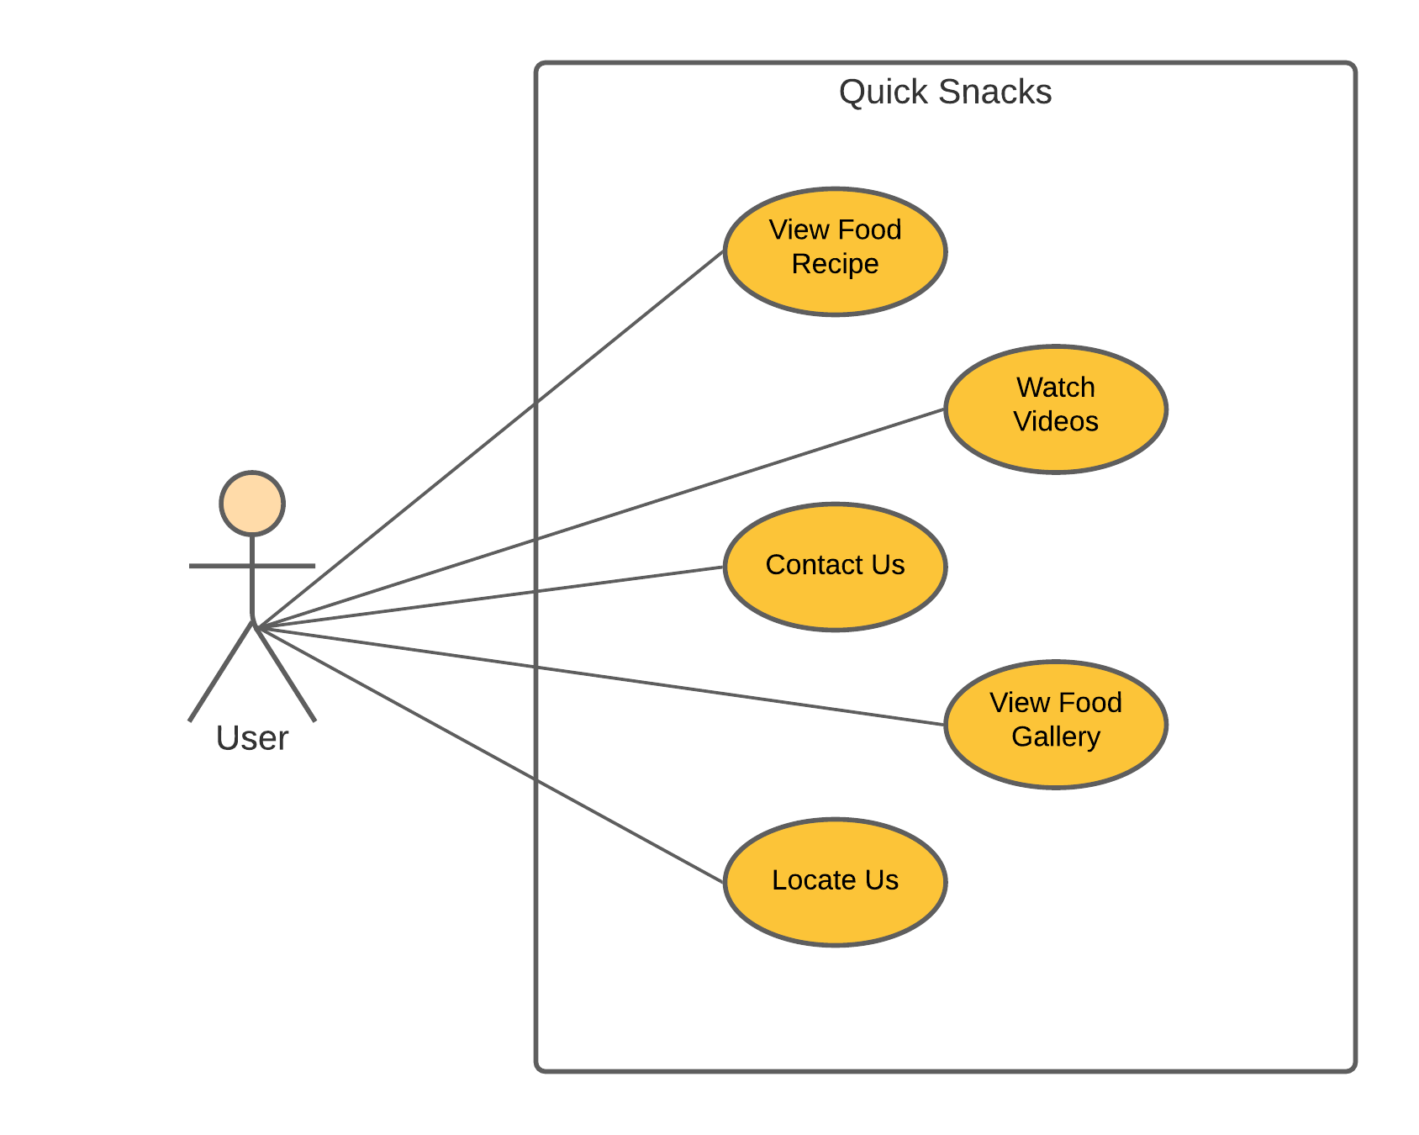

**2.3 Site Map**

**2.4 UI**

**Home**

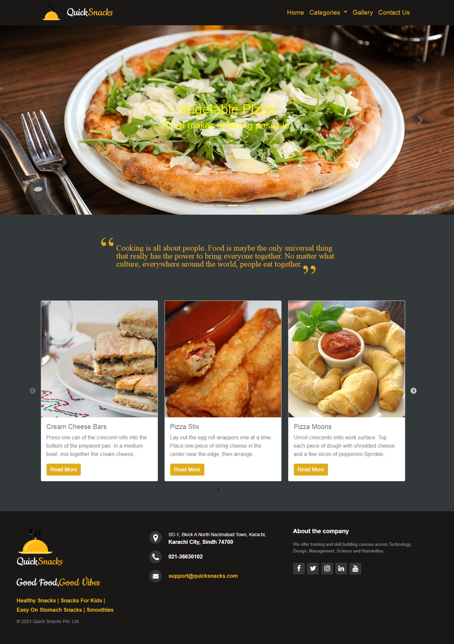

**Gallery**

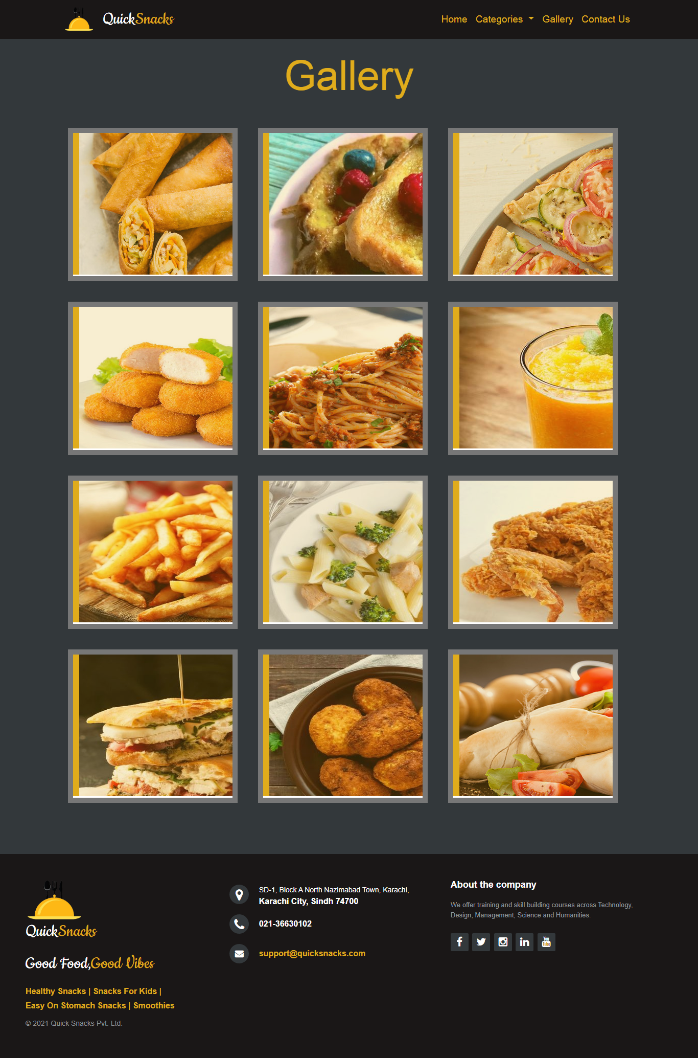

**Contact Us (With feedback)**

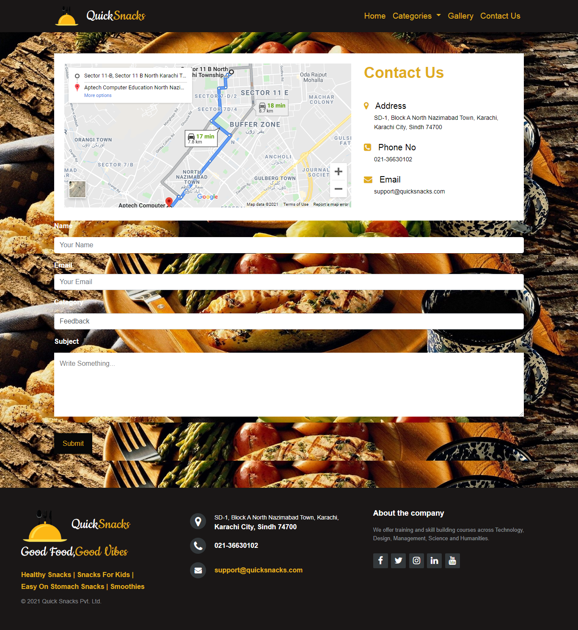

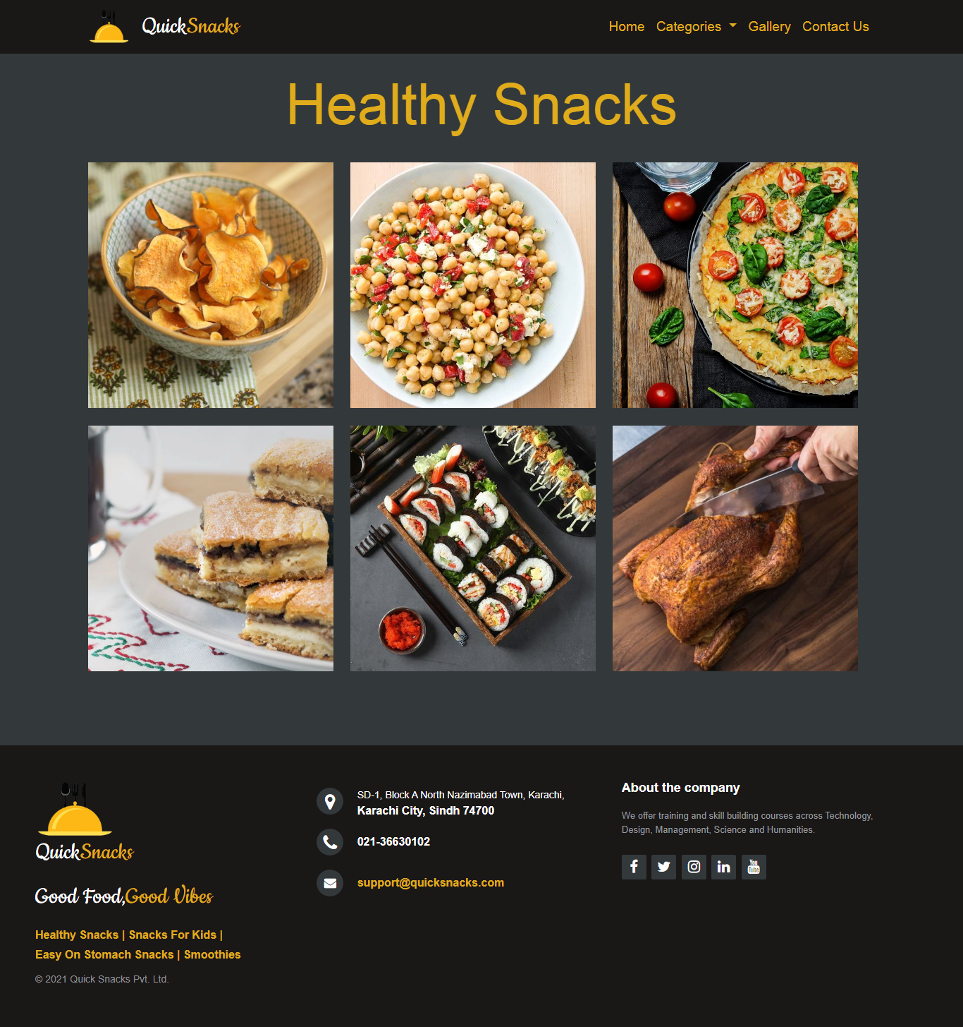**Healthy Snacks**

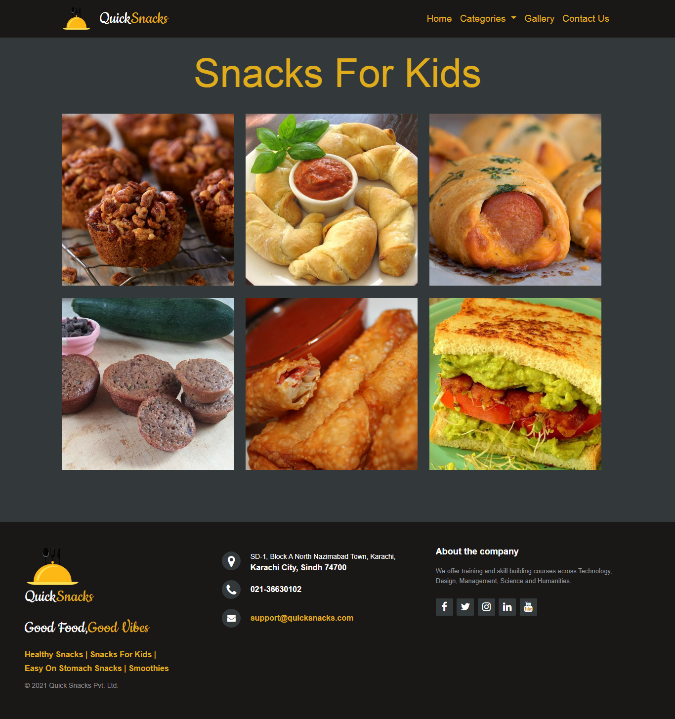**GALLERY**

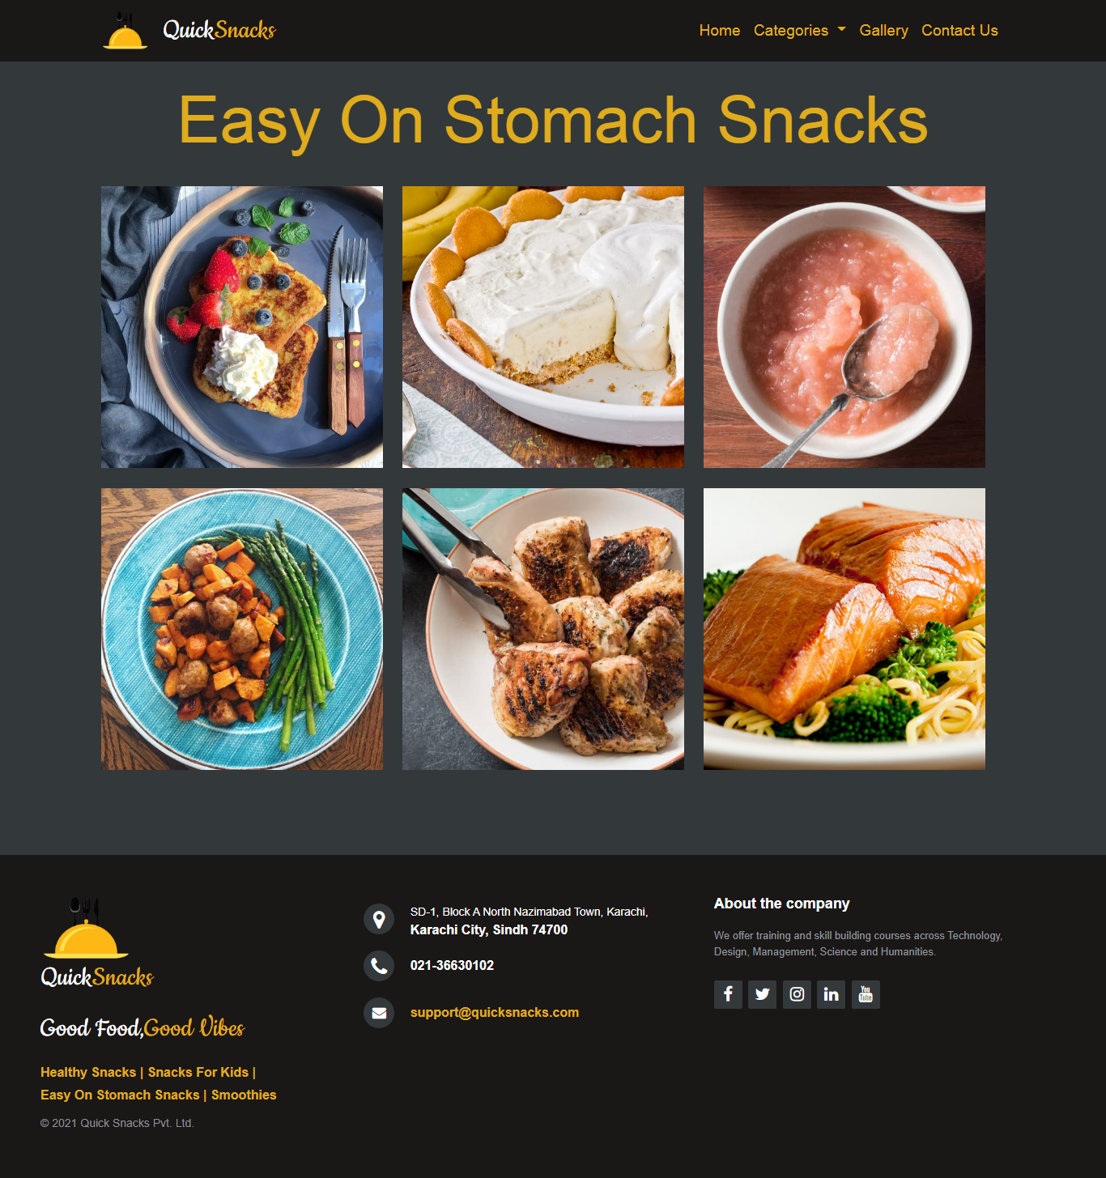**Easy on stomach snacks**

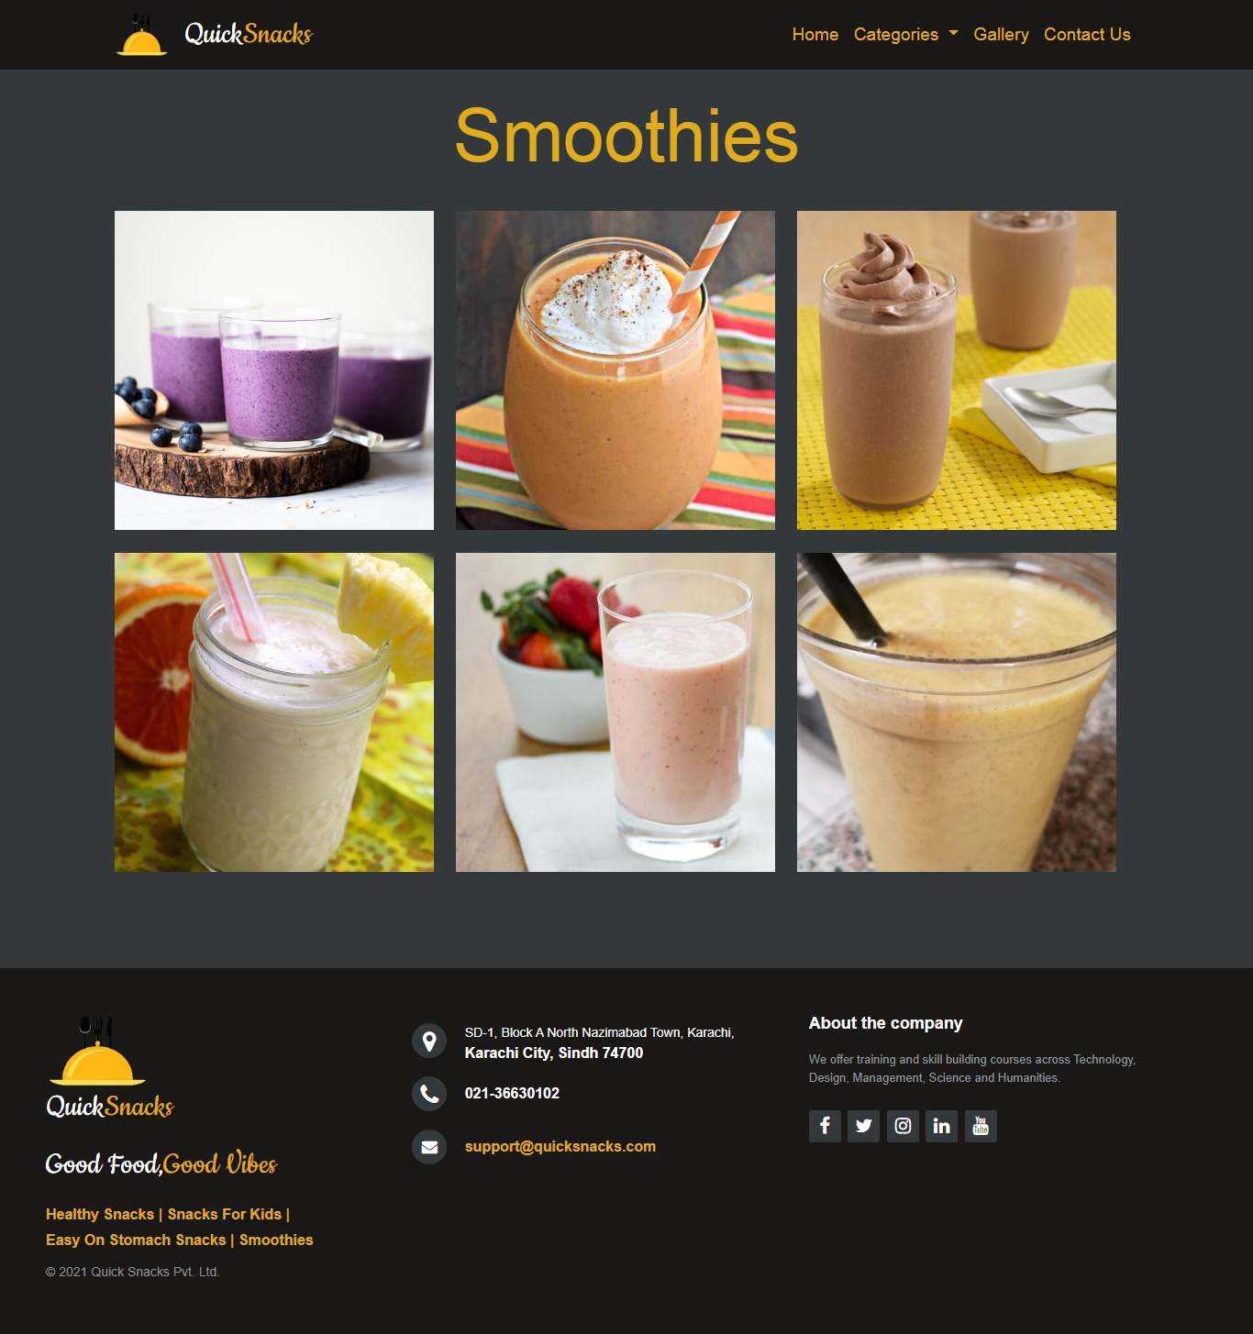**Smoothies**

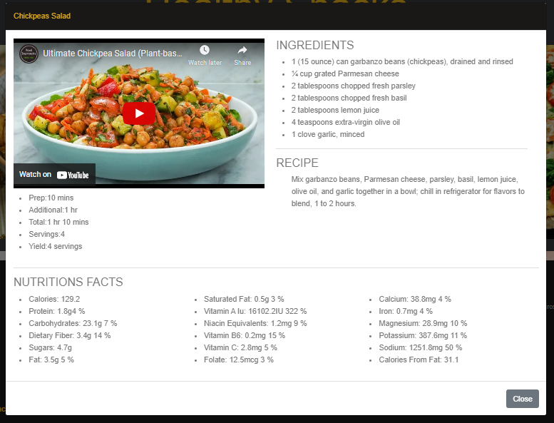**Modal**

**3. Task Sheet**

|  |  |  |  |  |  |
| --- | --- | --- | --- | --- | --- |
| **No.** | **Task** | **Actual Start Date** | **Actual Days** | **Team Mate Name** | **Status** |
| 1. | Analysis | 09 Mar, 2021 | 3 | All Members | Completed |
| 2. | Prototype | 12 Mar, 2021 | 3 | All Members | Completed |
| 3. | Data Collection | 15 Mar, 2020 | 3 | All Members | Completed |
| 4. | Site Interface Designing | 18 Mar, 2021 | 15 | All Members | Completed |
| 5. | Cross Browser Testing | 02 Apr, 2021 | 2 | All Members | Completed |
| 6. | Documentation | 04 Apr, 2021 | 5 | All Members | Completed |

**4. Submission Checklist**

|  |  |  |  |
| --- | --- | --- | --- |
| **No.** | **Requirement** | **Status** | **Comment/Reason** |
| 1. | All pages as per requirements given | **✓** |  |
| 2. | Links to all pages | **✓** |  |
| 3. | Layout and Color Scheme | **✓** |  |
| 4. | Browser Compatible | **✓** | Tested on Chrome and Firefox |
| 5. | Responsiveness | **✓** |  |
| 6. | Geo Location AP1 | **🗶** | API Key is not free, Iframe is used instead |
| 7. | Logo | **✓** |  |
| 8. | Project Reports (All three) | **✓** |  |
| 9 | Feedback Form | **✓** |  |
| 10. | Project Zip File | **✓** | WinRAR |

**5. Conclusion**

This overall project was bit challenging for us, but we have given our best and with the proper guidance of our instructor we have successfully completed this project in the given duration. This has helped us to boost our skills of building a static website and we have learned a lot from it. Many challenges were faced during the development of this website, but with proper management, guidance and team work we are able to do it.